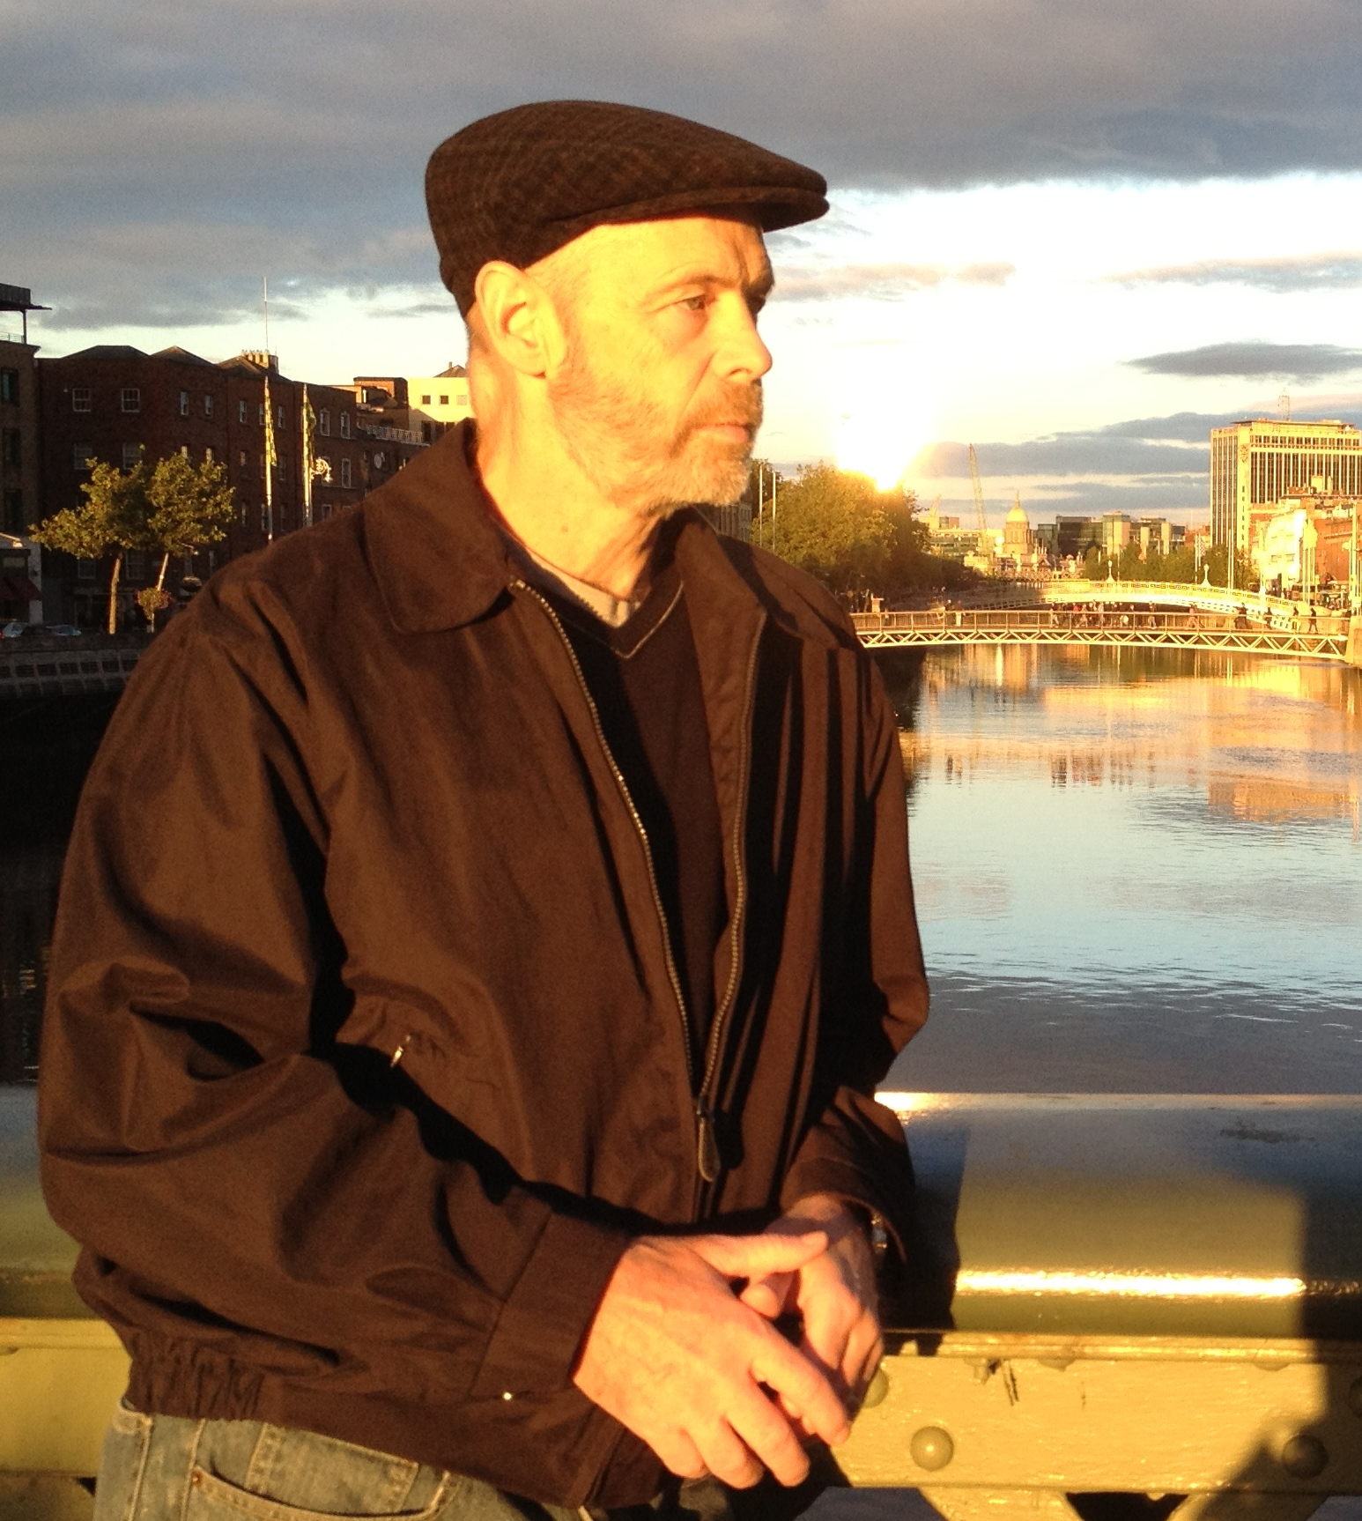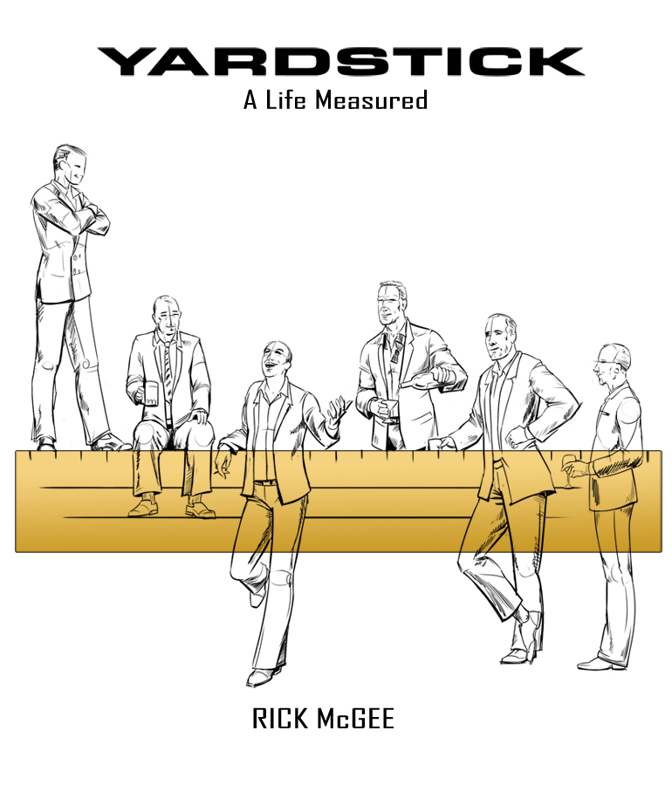

A portion of proceeds from book sales will be donated to the York High School Distinguished Alumni Program

Rick McGee spent thirty years in business with two large, international companies. He now advises organizations on defining and implementing their business design. He lives with his wife in Austin, Texas and can usually be found riding a bike around town, or at a UT game, looking for that next great story.

Saturday, June 21st

4pm-8pm

Join us in welcoming Author Rick McGee, York Graduate 1977. **Yardstick** is the fictional story of Coach Bob who is revealed to us through memories of his past and the reality of his present. **Yardstick** asks the question: How do you measure your life?

Author Event

Rickmcgeeauthor.com

Doc Ryan’s

490 Spring Road, Elmhurst, Il 60126, (630) 832-7753